Zadatk 1.
______________________________________________________________________________________________________________________________________________________________________________________________________________________________________________________
a =1 2  3 4  5 6  b =6 5  4 3  2 1 | c=a+b  c = 7 7  7 7  7 7  d=a-b  d = -5 -3  -1 1  3 5

Zadatak 2.
______________________________________________________________________________________________________________________________________________________________________________________________________________________________________________________
a =  1 4 6  3 2 5  9 2 -6  b =  9 23 87  -12 45 4  2 3 4 | c=a+b  c =  10 27 93  -9 47 9  11 5 -2 | d=a-b  d =  -8 -19 -81  15 -43 1  7 -1 -10 | e=a*b  e =  -27 221 127  13 174 289  45 279 767

Zadatak 3.
______________________________________________________________________________________________________________________________________________________________________________________________________________________________________________________
a =  1 4 6  3 2 5  9 2 -6  b =  9 23 87  -12 45 4  2 3 4 | c=a.*b  c =  9 92 522  -36 90 20  18 6 -24 | -za razliko od gore navedenog množenja tj. *(običnog množenja) kod množenja .*(član s članom) ovo množenje vrši se tako da se svaki element matrice a množi s njemu odgovarajućim elementom matrice b tj. Elemanta a[1,1] (1) će se množiti s elementom b[1,1] (9) i u rezultantnom matrici c imamo element [1,1] vrijednosti 9.

Zadatak 4.
______________________________________________________________________________________________________________________________________________________________________________________________________________________________________________________
a =  1 4 6  3 2 5  9 2 -6  b =  9 23 87  -12 45 4  2 3 4 | ad=det(a)  ad =  158  bd=det(b)  bd =  -8162 | ai=inv(a)  ai =  -0.1392 0.2278 0.0506  0.3987 -0.3797 0.0823  -0.0759 0.2152 -0.0633  bi=inv(b)  bi =  -0.0206 -0.0207 0.4684  -0.0069 0.0169 0.1323  0.0154 -0.0023 -0.0834

Zadatak 5.
______________________________________________________________________________________________________________________________________________________________________________________________________________________________________________________
a =  1 4 6  3 2 5  9 2 -6 | c=a(1,:)  c =  1 4 6 | d=ones(1,3)  d =1 1 1  c=d+c  c = 2 5 7

Zadatak 6.
______________________________________________________________________________________________________________________________________________________________________________________________________________________________________________________
t=0:0.05:15;  f=1.5;  y=cos(2*pi*f*t);  plot(y) | 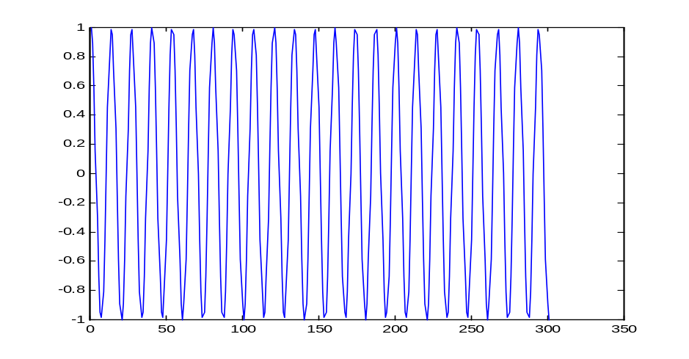
Zadatak 7.
______________________________________________________________________________________________________________________________________________________________________________________________________________________________________________________
korijeni=[-30 50 15+3j 15-3j]  korijeni =  -30.0000 50.0000  15.0000 + 3.0000i  15.0000 - 3.0000i  y=poly(korijeni)  y =1 -50 -666 40320 -351000 | t=-30:0.01:50;  p=polyval(y,t);  plot(p,'y','LineWidth',2)  hold on  plot(-p,':r','LineWidth',0.5)  xlabel('x-os')  ylabel('y-os')  title('Polinom')

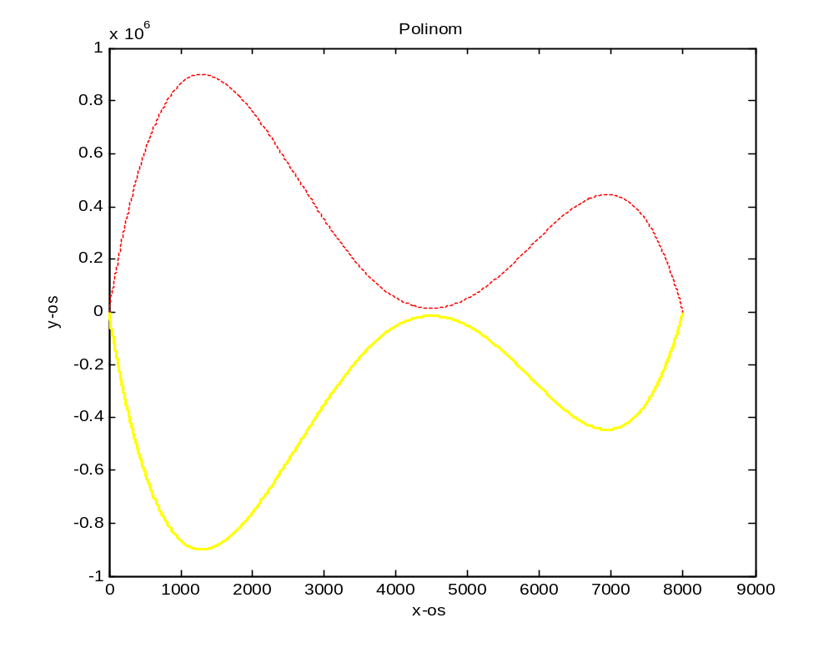

Zadatak 8.
______________________________________________________________________________________________________________________________________________________________________________________________________________________________________________________
x=0:0.01:20;  Y=200*exp(-0.05.*x).*sin(x);  plot(Y) | 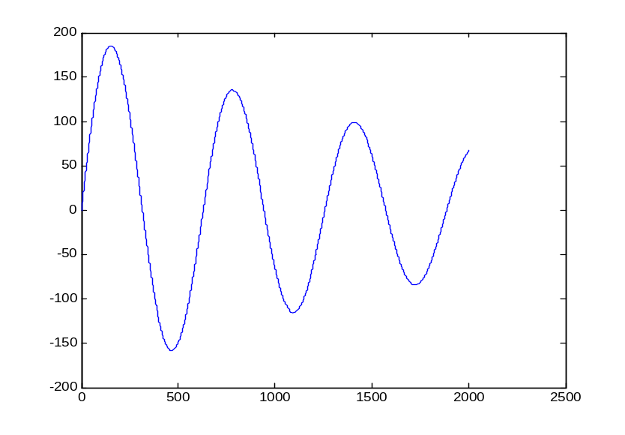

Zadatak 9.
______________________________________________________________________________________________________________________________________________________________________________________________________________________________________________________
Kod programa:  A=[1 2 8 9; 4 5 1 0];  K1=A(1,:);  K2=A(2,:);  t=0:0.1:20;  x1=polyval(K1,t);  x2=polyval(K2,t);  plot(x1,'r')  hold on  plot (x2,'b')  xlabel('x-os')  ylabel('y-os')  title('Polinomi') | 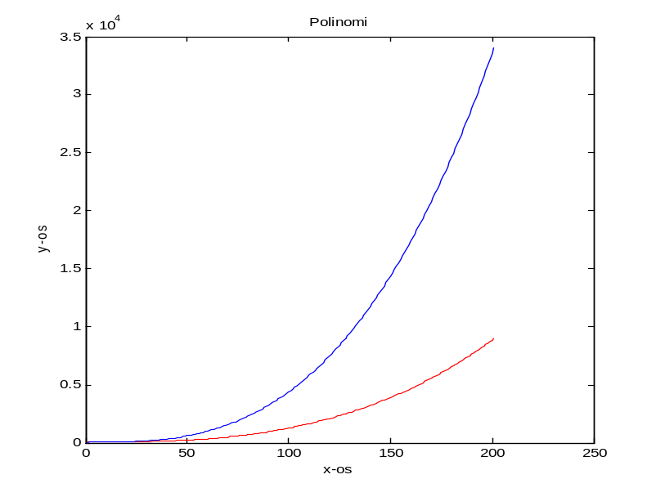

Zadatak 10.
______________________________________________________________________________________________________________________________________________________________________________________________________________________________________________________
Kod programa:  clear all  disp('Kada se matrice unose treba se napisati uglate zagrade')  A=input('Unesi prvu matricu ');  B=input('Unesi drugu matricu ');  x1=sum(A);  x2=sum(B);  if (x1>x2)  A  else  B  end | Kada se matrice unose treba se napisati uglate zagrade  Unesi prvu matricu [1 2 3]  Unesi drugu matricu [4 3 2]  B =  4 3 2

Zadatak 11.
______________________________________________________________________________________________________________________________________________________________________________________________________________________________________________________
Kod glavnog programa:  clear all  disp('Zadatak 11')  A=input('Unesi matricu ');  [st_dev]=devijacija(A);  disp('Standardna devijacije je:')  disp(st_dev)  Kod funkcije (podprograma):  function [st_dev]=devijacija(A)  x=length(A);  y=sum(A)/x;  for i=A  zbroj=(i-y)^2;  end  st_dev=sqrt((1/(y-1))*zbroj); | zadatak 11  Unesi matricu [1 2 3 4 5]  Standardna devijacije je:  1.4142

Zadatak 12.
______________________________________________________________________________________________________________________________________________________________________________________________________________________________________________________
Kod programa:  clear all  disp('Zadatak 12')  x=0:0.1:20;  y1=x.*sin(3*x);  y2=5*y1-x;  subplot(2,1,1);  plot(x,y1,'k');  xlabel('x-os')  ylabel('y-os')  title('Graf 1')  subplot(2,1,2);  plot(x,y2,':r');  xlabel('x-os')  ylabel('y-os')  title('Graf 2'); | 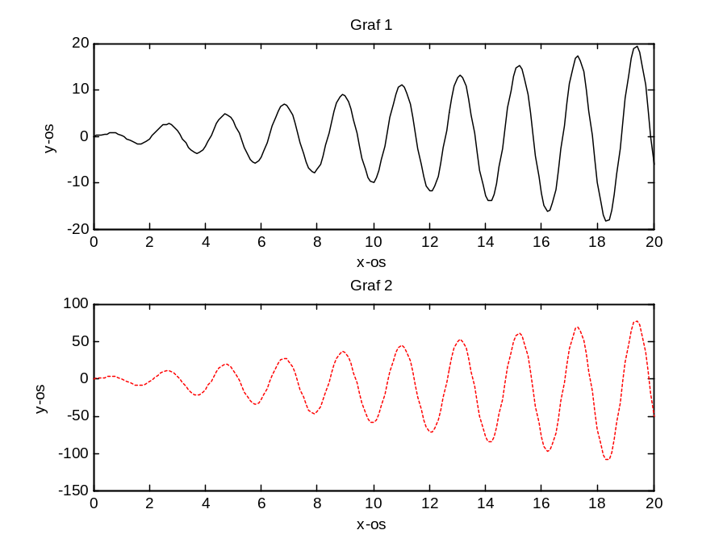

Zadatak 13.
______________________________________________________________________________________________________________________________________________________________________________________________________________________________________________________
Kod programa:  clear all  disp('Zadatak 13')  x=-3:0.05:10;  y=5*x.*exp(-3*x);  plot(x,y,':y');  xlabel('x-os')  ylabel('y-os')  title('Graf'); | 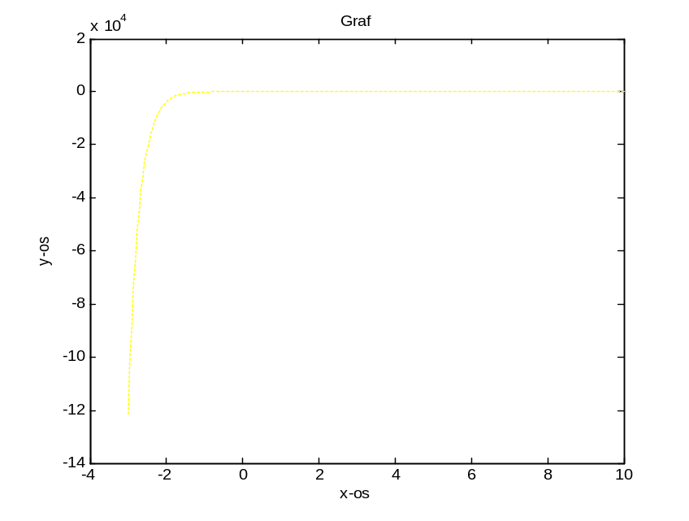
Zadatak 14.
______________________________________________________________________________________________________________________________________________________________________________________________________________________________________________________
Kod programa:  clear all  disp('Zadatak 14')  b=input('element--> ');  if(b>=0)  a(1,1)=b;  else  end;  i=1;  while(b>=0)  i=i+1;  b=input('element--> ');  if(b>=0)  a(i,1)=b;  end  end  disp('a prije sortiranja:')  a  disp('a poslije sortiranja:')  a=sort(a);  a | Zadatak 14  element--> 11  element--> 32  element--> 8  element--> 4  element--> 5  element--> 2  element--> 9  element--> -1  a prije sortiranja:  a =  11  32  8  4  5  2  9  a poslije sortiranja:  a =  2  4  5  8  9  11  32

